Launch “Credential Manager”

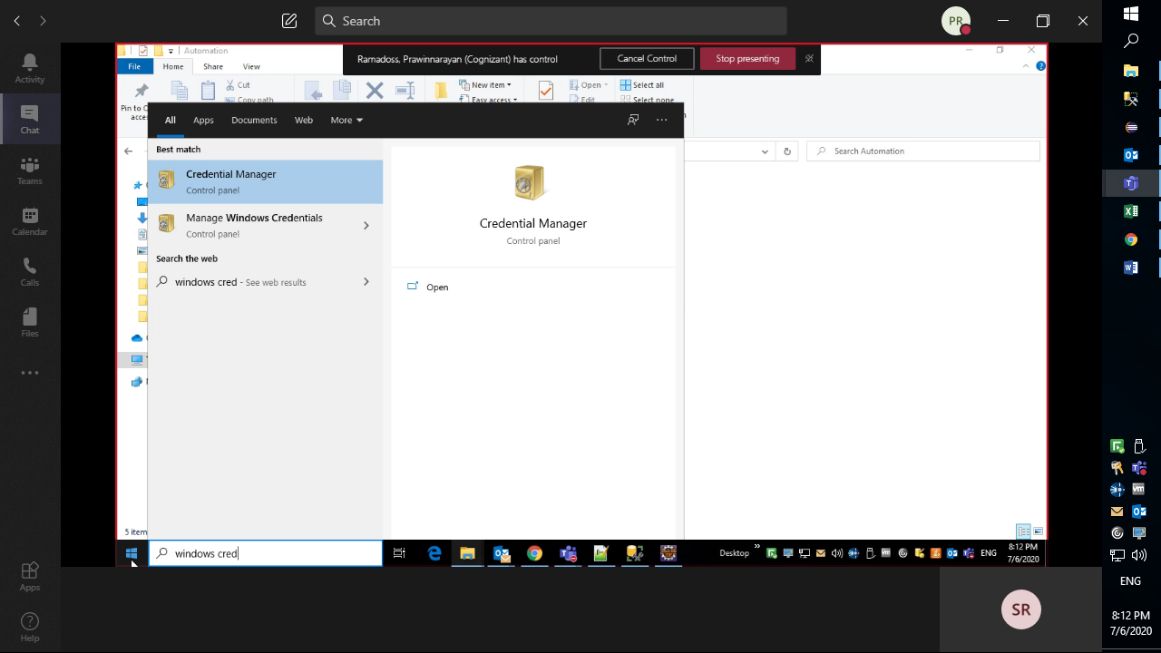

Select “Windows Credentials” tab.

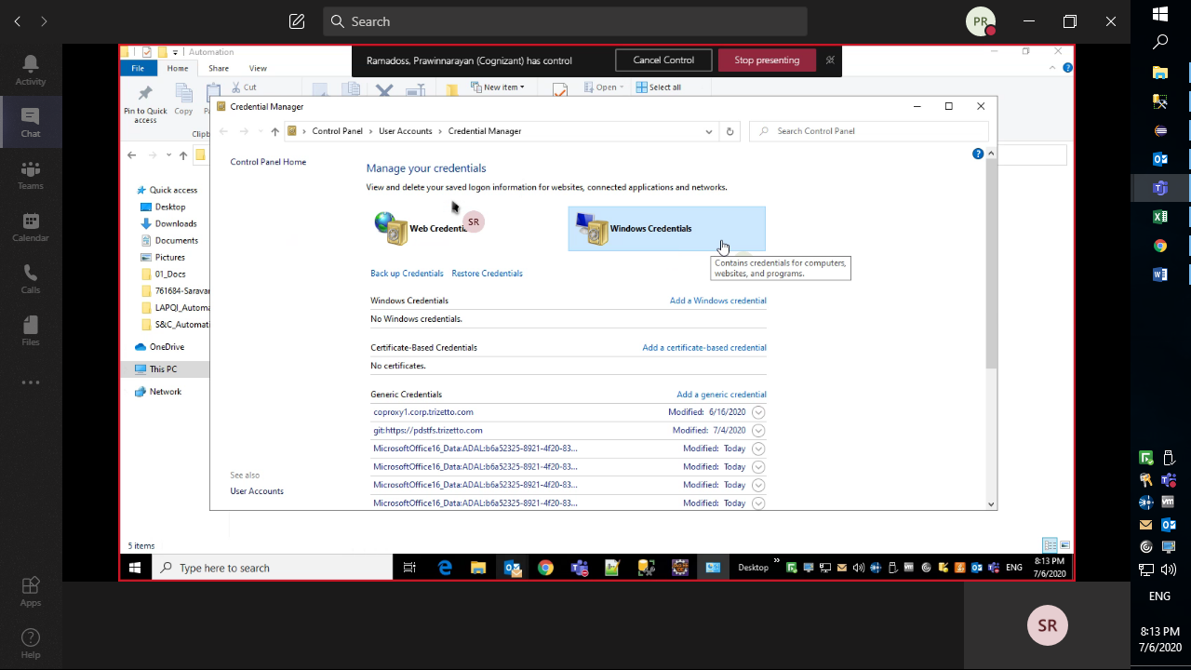

Click “Add a Windows credentials” link

Enter details: **Network Address**: AutomationUser / **User Name**: <Associate ID> / **Password**: VDI Password

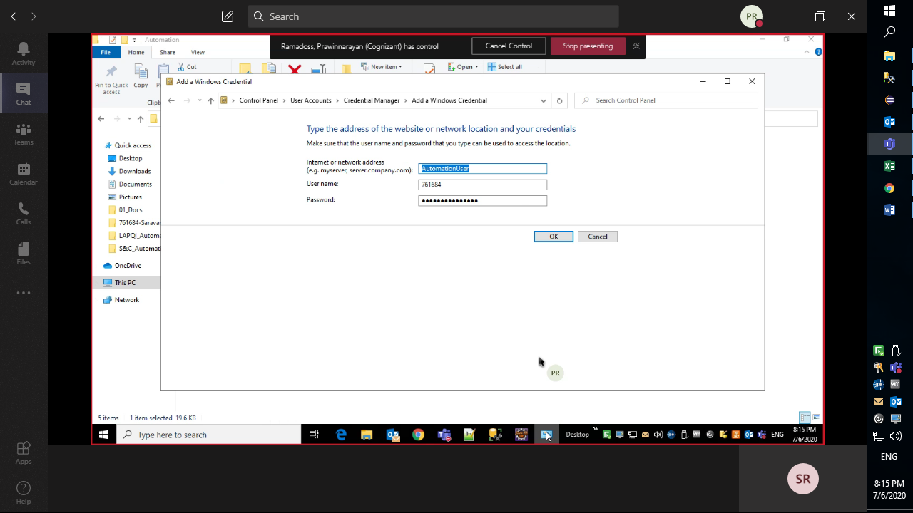

Verify the same under “Windows Credentials”

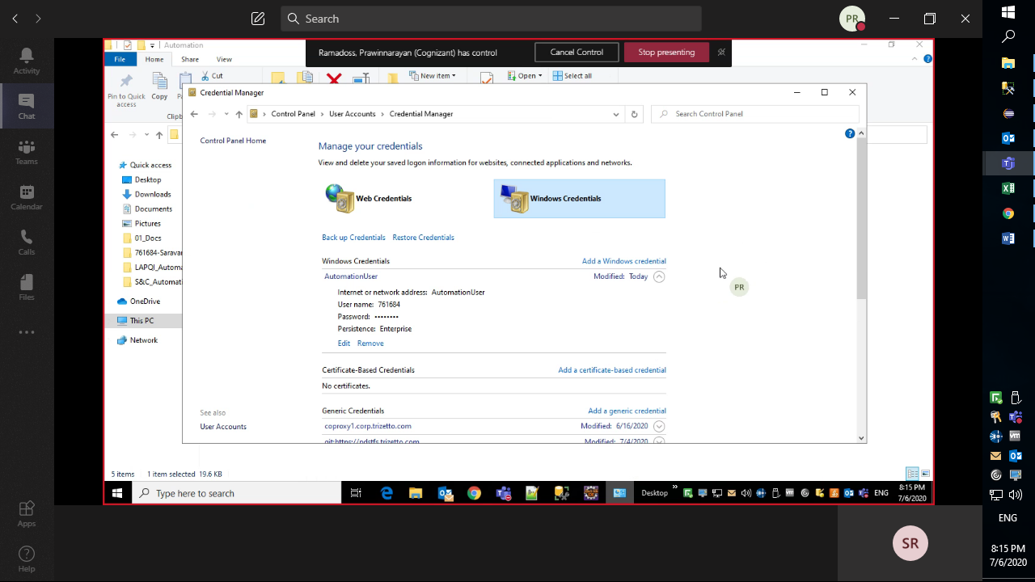

Click “Add a generic credentials” link

Enter Details: **Network Address**: AutomationUser / **User Name**: <Associate ID> / **Password**: VDI Password

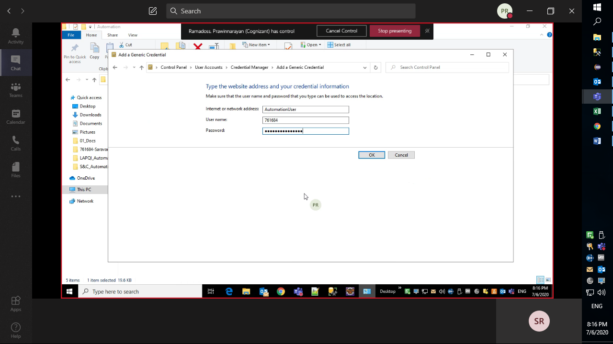

Verify the same.

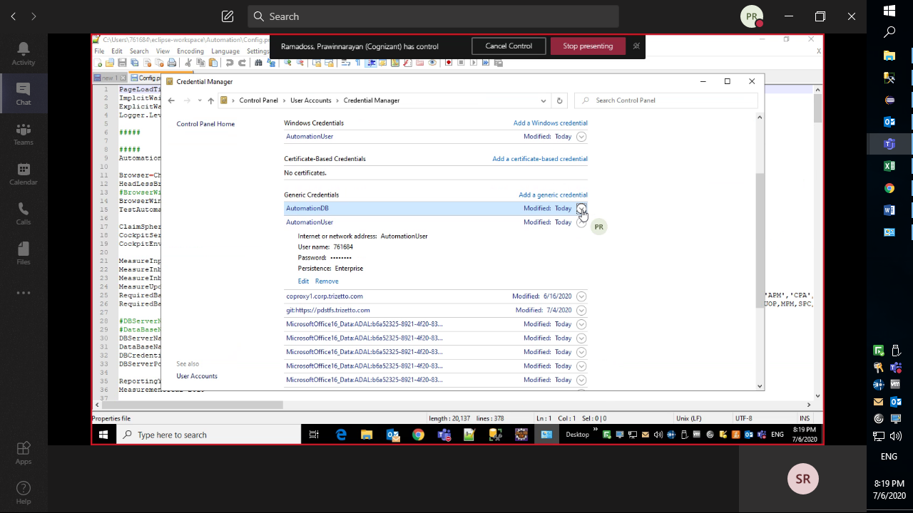

Click on “Add a generic credentials” link

Enter Details: **Network Address**: AutomationDB / **User Name**: CSQA / **Password**: Welcome@123

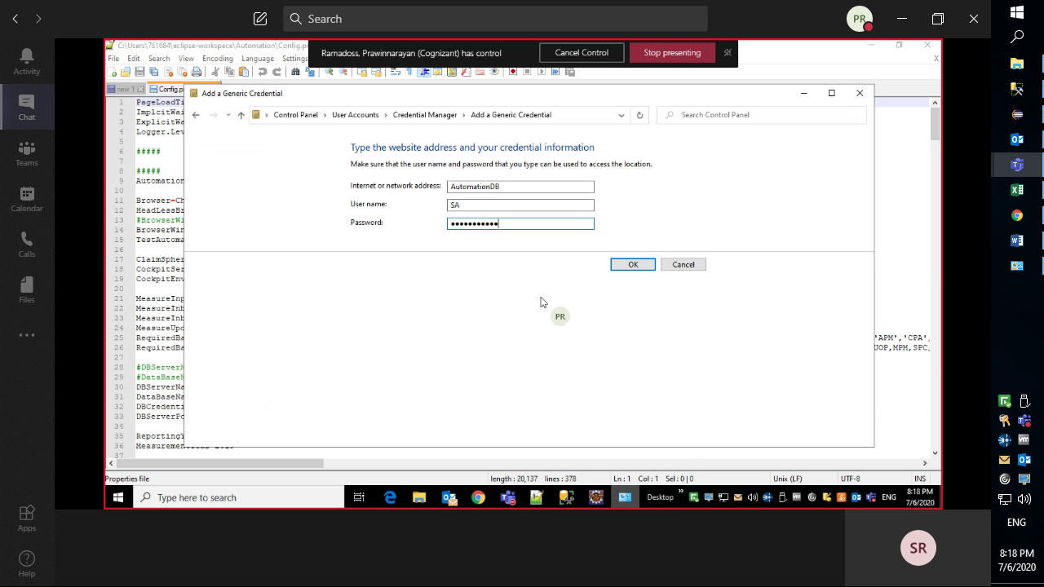

Verify the same

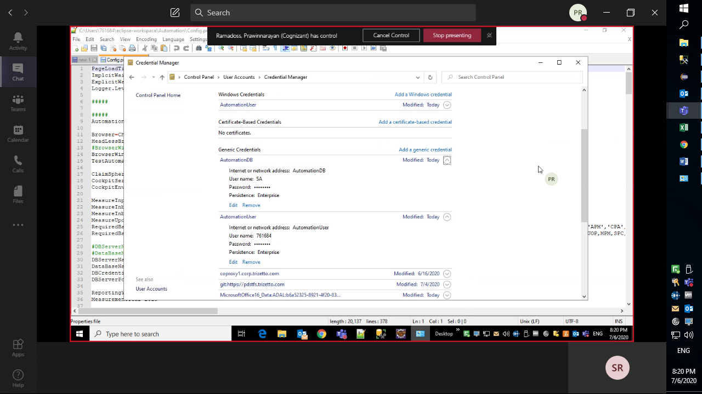

Your Windows credentials set up is done.